An Internship Report
Of
Blockchain Fundamentals & Web3 Integration
Submitted
To
School of Computer Science and Engineering
IILM University, Greater Noida, U.P.
In partial fulfilment of the requirement of degree of
B. Tech (CSE - AIML)

By
Roll Number of Student:- 25SCS1003002339
Name of Student: GAURAV PANDEY
Batch: 2025-2029

CANDIDATE'S DECLARATION
I, GAURAV PANDEY, do hereby declare that the internship report titled “Blockchain Fundamentals & Web3 Integration” has been completed by me to fulfil the requirement for the award of the degree of Bachelor of Technology in Computer Science and Engineering (AIML). All the references have been quoted and I have not taken as such any material from any other source. I affirm that this report is my own and has not been submitted to any other institute for any degree/diploma requirement, and further I shall be solely responsible for any kind of copyright violation in this regard.
Signature:-
Student Name: GAURAV PANDEY
Roll No.: 25SCS1003002339

ACKNOWLEDGEMENT
I am using this opportunity to express my gratitude to everyone who supported me throughout the internship. I am thankful for their aspiring guidance, invaluably constructive criticism, and friendly advice during this work. I am sincerely grateful to them for sharing their truthful and illuminating views on a number of issues related to blockchain technology and Web3 development.
I would like to thank BlockseBlock and my mentors for providing me the opportunity and a structured platform to learn and gain hands-on exposure in the domain of Blockchain Fundamentals and Web3 Integration during my tenure as a Blockchain Developer Intern from 1st June 2026 to 31st August 2026. I am also thankful to my institute, IILM University, Greater Noida, and the faculty of the School of Computer Science and Engineering for their continuous support and encouragement.
I express my gratitude to my parents for their blessings.
Signature:
Student Name: GAURAV PANDEY
Roll No.: 25SCS1003002339

TABLE OF CONTENTS
1. Candidate's Declaration i
2. Acknowledgement ii
3. Internship Completion Certificate -
4. Project Description 1
4.1 Introduction 1
4.2 Organization Profile 2
4.3 Problem Statement 3
4.4 Project Objectives 3
4.5 Scope of the Project 4
4.6 Technologies and Tools Used 4
4.7 System Architecture 5
4.8 Methodology 6
4.9 Expected Outcomes 7
4.10 Certificate of Completion 8
5. Bibliography/References 9

3. INTERNSHIP COMPLETION CERTIFICATE
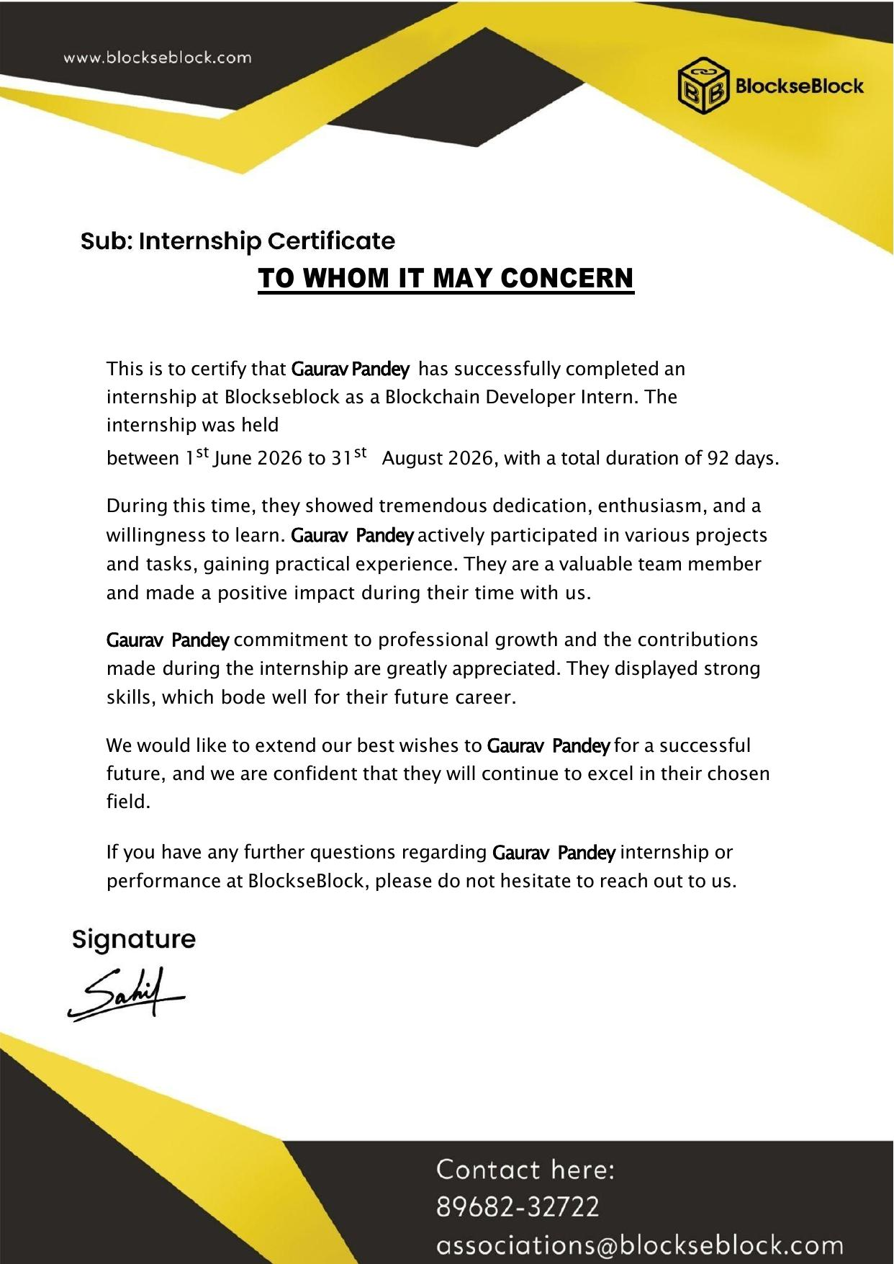

4. PROJECT DESCRIPTION

4.1 Introduction
This report presents a detailed account of the internship undertaken at BlockseBlock, in the domain of “Blockchain Fundamentals & Web3 Integration.” The internship was carried out from 1st June 2026 to 31st August 2026, spanning a total duration of 92 days, as part of the requirement of the Bachelor of Technology (Computer Science and Engineering – AIML) programme at IILM University, Greater Noida. The primary aim of this internship was to build a strong conceptual foundation in blockchain technology and gain practical, hands-on exposure to Web3 development – including how decentralized applications interact with blockchain networks, wallets, and smart contracts.
During the internship, practical exposure was gained on core blockchain concepts such as distributed ledgers, consensus mechanisms, cryptographic hashing, and smart contracts, alongside Web3 integration practices such as connecting front-end applications to blockchain networks using wallets and Web3 libraries. On successful completion of all assigned tasks and project work, an Internship Completion Certificate was awarded by BlockseBlock.

4.2 Organization Profile
BlockseBlock is a technology organization focused on blockchain development and Web3 solutions. The organization provides internship and training programs that allow learners to gain practical, project-based experience in blockchain fundamentals, smart contract development, and decentralized application (DApp) integration, helping engineering students strengthen their employability and gain exposure to the rapidly growing Web3 ecosystem.

4.3 Problem Statement
While a large number of engineering students study the theoretical foundations of blockchain technology as part of their academic coursework, very few get direct, hands-on exposure to how blockchain networks function in practice and how real-world applications integrate with them. Understanding the underlying architecture of a blockchain is only one part of the learning curve; being able to interact with a live network, connect a wallet, and integrate Web3 functionality into an application is an equally important and often overlooked skill. The problem addressed by this internship was to build a practical understanding of blockchain fundamentals and to implement Web3 integration – connecting applications to blockchain networks, interacting with smart contracts, and using wallet-based authentication.

4.4 Project Objectives
- To understand the fundamental concepts of blockchain technology, including distributed ledgers, blocks, hashing, and consensus mechanisms.
- To learn the working principles of public blockchain networks such as Ethereum.
- To gain hands-on exposure to smart contracts and their role in decentralized applications.
- To understand wallet-based authentication using tools such as MetaMask.
- To learn Web3 integration using libraries such as Web3.js/Ethers.js to connect front-end applications to blockchain networks.
- To explore decentralized application (DApp) architecture and its interaction with smart contracts.
- To understand the basics of token standards and transactions on the blockchain.
- To apply the above concepts in practical assignments and tasks during the internship.

4.5 Scope of the Project
The scope of this internship covers the foundational layer of blockchain technology and its integration into Web-based applications – starting from understanding how a blockchain network stores and validates data, moving to smart contract interaction, and finally connecting a front-end application to the blockchain using Web3 libraries and wallet integration. The internship was carried out in a structured, mentor-guided environment provided by BlockseBlock and was focused on conceptual understanding along with applied Web3 integration tasks.

4.6 Technologies and Tools Used
- Blockchain Concepts: Distributed Ledger Technology, Consensus Mechanisms, Cryptographic Hashing
- Blockchain Network: Ethereum (public blockchain fundamentals)
- Smart Contracts: Solidity basics, contract interaction
- Wallet Integration: MetaMask
- Web3 Libraries: Web3.js / Ethers.js
- Front-End Integration: HTML, CSS, JavaScript
- Version Control: Git and GitHub

4.7 System Architecture
The general architecture followed for Web3 integration during the internship can be summarized in the following layers:
- Blockchain Layer: The underlying distributed ledger (Ethereum) that stores transactions and executes smart contracts.
- Smart Contract Layer: Contracts deployed on the blockchain that define the rules and logic of the decentralized application.
- Wallet Layer: MetaMask or similar wallets used for identity, authentication, and signing transactions.
- Web3 Integration Layer: Libraries such as Web3.js/Ethers.js that allow a front-end application to communicate with the blockchain network and smart contracts.
- Application Layer: The front-end interface through which a user interacts with the decentralized application.

4.8 Methodology
The internship followed a structured, mentor-guided methodology combining conceptual learning with hands-on tasks, as summarized in the table below.
Period | Module | Description
Weeks 1-2 | Blockchain Foundations | Introduction to blockchain technology, distributed ledgers, blocks, cryptographic hashing, and consensus mechanisms; setting up the development environment.
Weeks 3-4 | Ethereum & Smart Contracts | Understanding the Ethereum network, wallets, gas fees, and the basics of smart contracts and Solidity.
Weeks 5-6 | Wallet Integration | Working with MetaMask for wallet-based authentication and understanding transaction signing.
Weeks 7-9 | Web3 Integration | Using Web3.js/Ethers.js to connect front-end applications to the blockchain, reading contract data, and sending transactions.
Weeks 10-11 | DApp Architecture | Understanding decentralized application architecture and how front-end, wallet, and smart contract layers interact.
Weeks 12-13 | Applied Tasks & Wrap-up | Practical assignments applying blockchain fundamentals and Web3 integration concepts, review, and internship wrap-up.
Throughout the internship, tasks and assignments were reviewed by the mentor, and feedback was incorporated on an ongoing basis. On successful completion of all assigned work, the internship was concluded with the issuance of a completion certificate.

4.9 Expected Outcomes
- A clear conceptual understanding of blockchain technology, including distributed ledgers, consensus mechanisms, and cryptographic hashing.
- Practical familiarity with the Ethereum network and the role of smart contracts.
- Hands-on experience with wallet-based authentication using MetaMask.
- Ability to integrate a front-end application with a blockchain network using Web3.js/Ethers.js.
- Understanding of decentralized application (DApp) architecture.
- A completed set of practical assignments demonstrating blockchain fundamentals and Web3 integration.

4.10 Certificate of Completion
The Internship Completion Certificate issued by BlockseBlock, confirming successful completion of the 92-day internship as a Blockchain Developer Intern in the domain of Blockchain Fundamentals & Web3 Integration, is attached in Chapter 3 of this report.

5. BIBLIOGRAPHY/REFERENCES
1. BlockseBlock, “Internship Certificate – Blockchain Developer,” issued to Gaurav Pandey, 2026.
2. Ethereum Documentation, https://ethereum.org/en/developers/docs/
3. Solidity Documentation, https://docs.soliditylang.org/
4. Web3.js Documentation, https://web3js.readthedocs.io/
5. Ethers.js Documentation, https://docs.ethers.org/
6. MetaMask Developer Documentation, https://docs.metamask.io/

